Textbook declutter is an app where people can donate their academic books to people. It is like the Book Santa application. The first screen is the signup screen where the user has to enter his personal details:

* Name
* Email
* Password
* confirm password
* phone number
* Address (Building name, Flat no, Locality, Landmark, City, Pin code, State)

If the user already has an account, then he can login using his name and password. The app will then show a donate book screen where the donor will have to enter details:

* The name of the school to which the books belong
* Which grade the textbooks pertained to
* Which board the textbooks belong to
* The donor will have to write a brief description of the books being donated.

Another user who wants a book will go to the search screen and using the filters will search for the books. With the help of the filters, he can find the books.

There is also a setting screen where the user can change his personal details and profile picture. There is also a hamburger icon and when the user clicks, he will be able to see the side drawer in which the user will be able to move to the other screen like the donated books, received books, notification screen and lastly the setting screen. The users will receive notifications when someone has accepted their book donation and if someone is ready to donate their books.

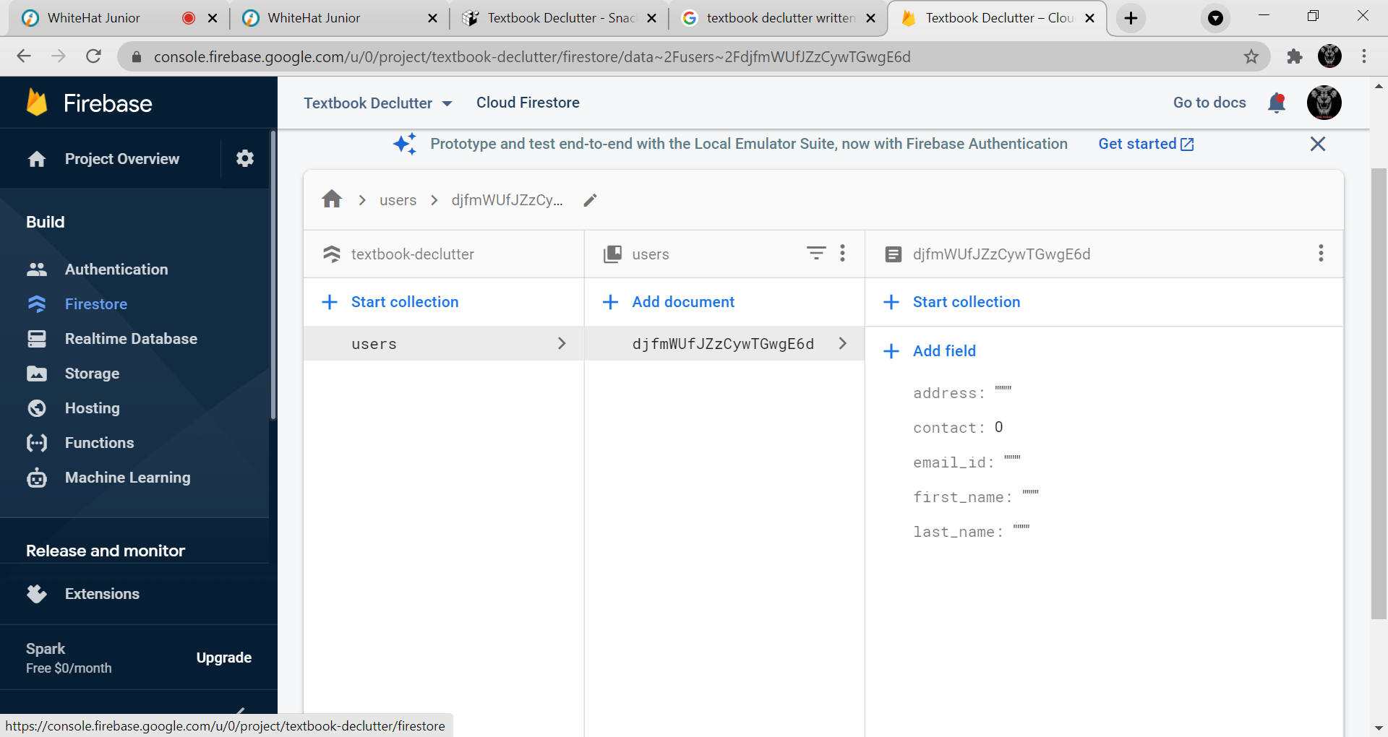dss